**Session 16 – Assignment 1**

**Problem Statement 1:**

A test is conducted which is consisting of 20 MCQs (multiple choices questions) with

every MCQ having its four options out of which only one is correct. Determine the

probability that a person undertaking that test has answered exactly 5 questions wrong.

**Code:**

import numpy as np

import pandas as pd

import scipy.stats as stats

# Let us say Total Number of Mulitiple Choices Questions is n

n = 20

# MCQ having its four options out of which only one is correct Probability of giving a right answer => s

s = 1/4

# Probability that a person answers 5 questions wrong n - k = 20 - 15 = 5

x = 5

# Probability of giving a wrong answer => [1 - s = 1 - 1/4 = 3/4]

# Probability p = (exactly 5 out of 20 answers incorrect) = C (20, 5) * (1/4)^15 * (3/4)^5

# Probability p = ((20*19) ∗ (18 ∗ 17) ∗ 16) / (5 ∗ 4 ∗ 3 ∗ 2 ∗ 1) * (1/4)^1 5 * (3/4)^5

p=(20*19*18*17*16)/(5*4*3*2*1)*(1/4)**15*(3/4)**5

display(p)

**Output:**

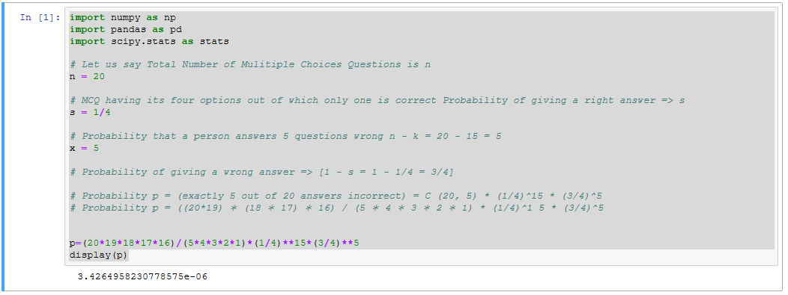

**Problem Statement 2:**

A die marked A to E is rolled 50 times. Find the probability of getting a “D” exactly 5

times.

**Code:**

#A die marked A to E is rolled 50 times. Find the probability of getting a “D” exactly 5 times.

#Here, n = 50, k = 5, n - k = 45.

#The probability of success = probability of getting a “D”= s = 1/5,

#Hence, the probability of failure = probability of not getting a “D” = 1 - s = 4/5.

#P(X=D)=(50c5)(1/5)^5 (4/5)^45 = (2118760)* (0.00032) *(0.00004355614) = 0.029531202299648

S=(2118760)* (0.00032) *(0.00004355614)

display(S)

**Output**:

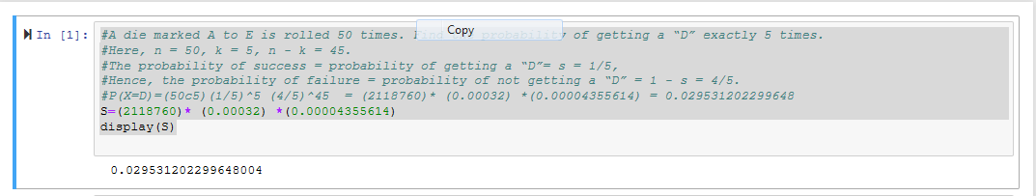

**Problem Statement 3:**

Two balls are drawn at random in succession without replacement from an urn

containing 4 red balls and 6 black balls.

Find the probabilities of all the possible outcomes.

**Code:**

#4 Red and 6 Black Balls => Total Balls 10

#Total ways to draw two balls 10 * 9 = 90

# ways to draw Two red balls = 4 * 3 = 12 , One Red then One Black 4 * 6 = 24 , one Balck then Red = 6 * 4 = 24

# Two Blacks 6 * 5 = 30

# Total = (RR + RB + BR + BB) = (12 + 24 + 24 + 30) = 90

# Probability of Possible Outcomes P

# Red Balls R

# Black Balls B

# Total Balls T

R = 4

B = 6

T = R + B

display(T)

# No possibiblities

# N = n*(n-1)

N = 10*9

display(N)

# Probablity to get two Red

RR = 4*3

display(RR/N)

# Probablity to get one Red and one Black

RB = 4*6

BR = 6*4

display((24/90)+(24/90))

#Probablity to get two blacks

BB=6*5

display((6*5)/N)

**Output**:

